









   





























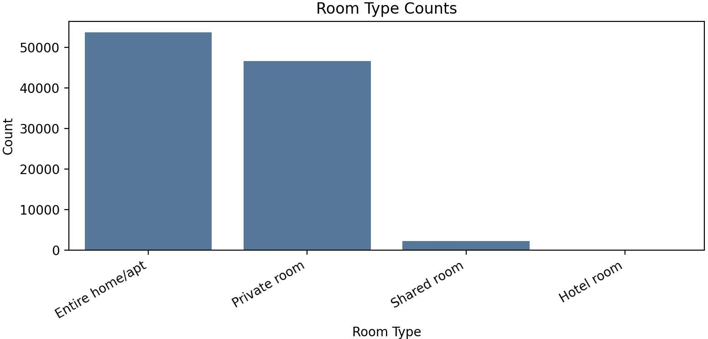









|  |  |
| --- | --- |
|  |  |
|  |  |
|  |  |
|  |  |
|  |  |
|  |  |
|  |  |
|  |  |

|  |  |
| --- | --- |
|  |  |
|  |  |













|  |  |
| --- | --- |
|  |  |
|  |  |
|  |  |
|  |  |
|  |  |
|  |  |
|  |  |
|  |  |
|  |  |





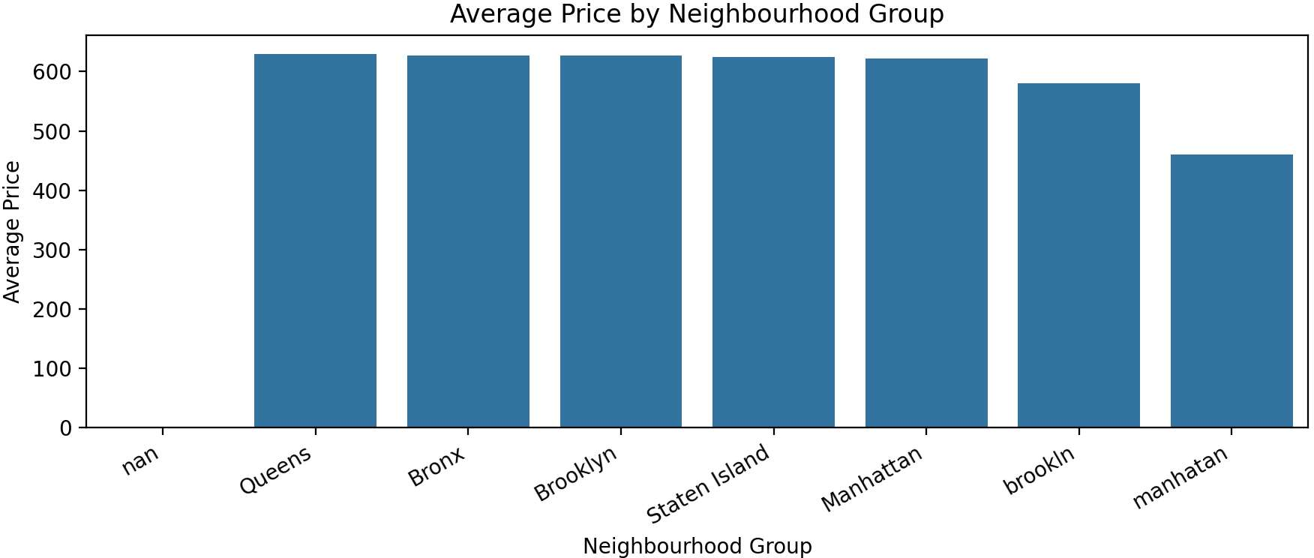

















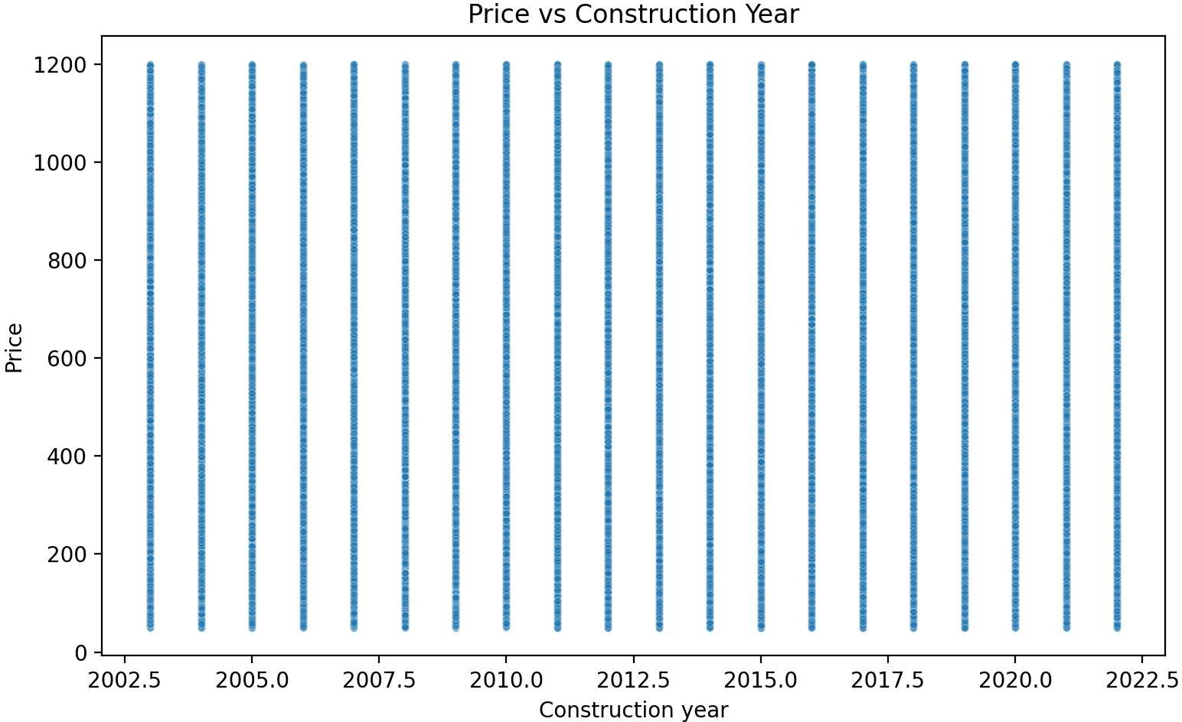











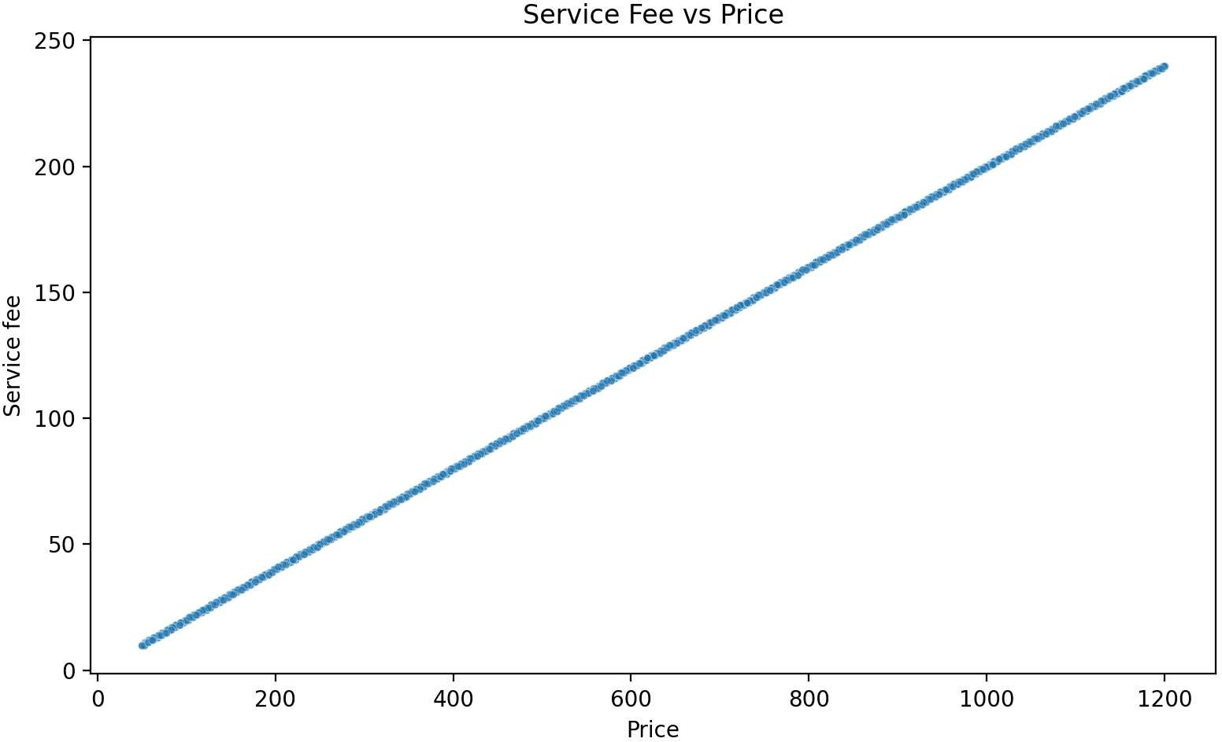













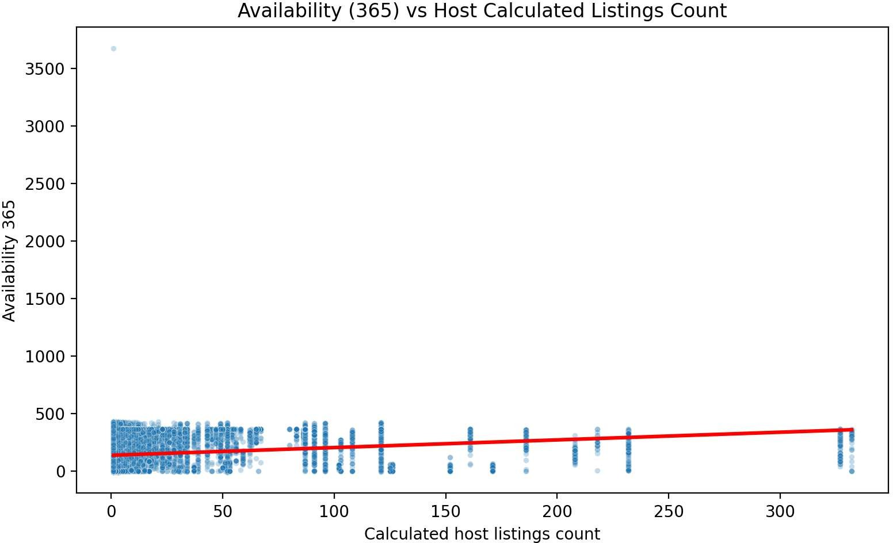







|  |  |
| --- | --- |
|  |  |
|  |  |
|  |  |
|  |  |
|  |  |

|  |  |
| --- | --- |
|  |  |
|  |  |
|  |  |
|  |  |
|  |  |
|  |  |
|  |  |







|  |  |
| --- | --- |
|  |  |
|  |  |
|  |  |



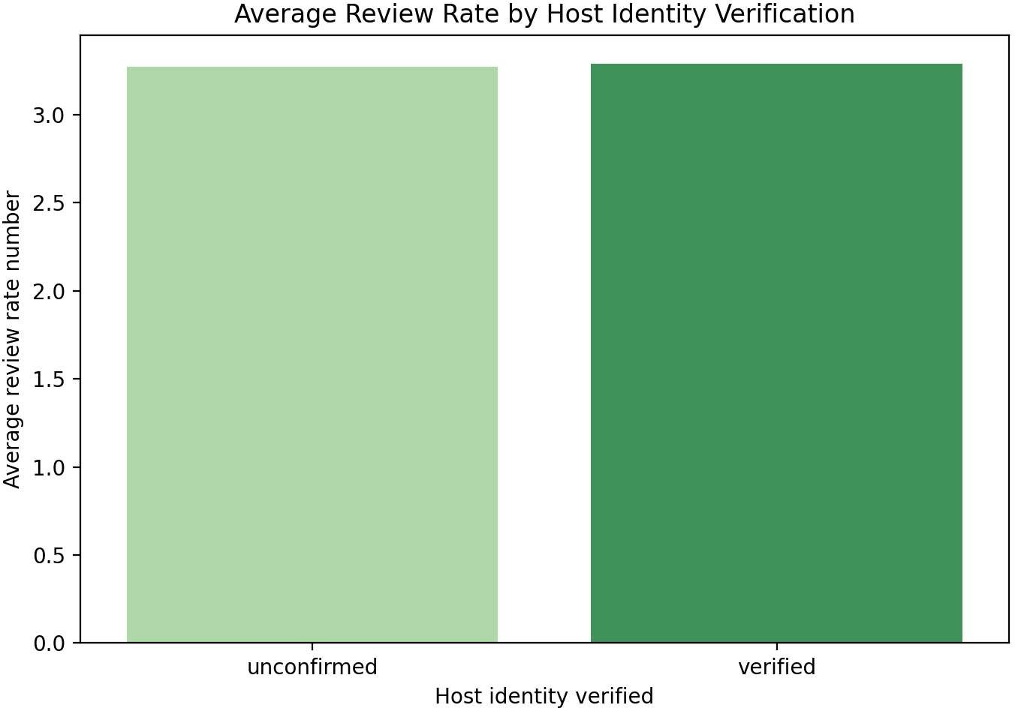









|  |  |  |  |  |
| --- | --- | --- | --- | --- |
|  |  |  |  |  |
|  |  |  |  |  |
|  |  |  |  |  |
|  |  |  |  |  |

|  |  |  |  |  |
| --- | --- | --- | --- | --- |
|  |  |  |  |  |
|  |  |  |  |  |
|  |  |  |  |  |
|  |  |  |  |  |
|  |  |  |  |  |





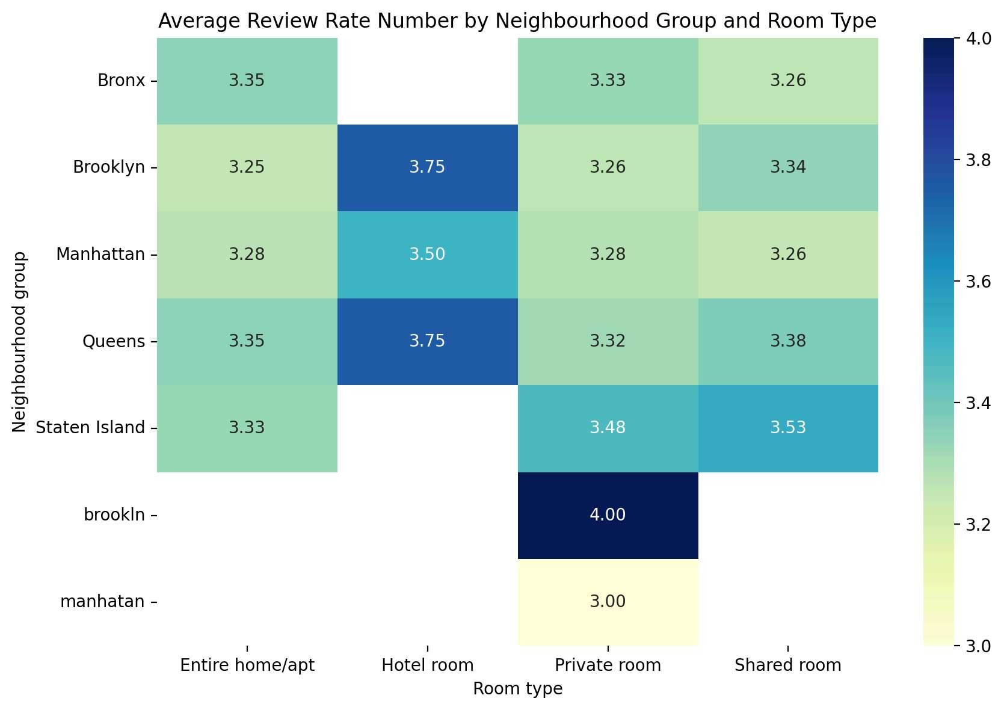













**Conclusion**



